SECTION SPECIFICATION

**Does it help or harm the environment? How does its environmental impact compare to previous forms of technology? Is the environment better off with or without it?**

The idea of green energy is presented as an alternative source of renewable natural energy in replacement to fossil fuels. Renewable energy is any type of energy which can come from any resources like wind, rain, sunlight, and etc. The goal of this section is to describe what environmental impacts green energy does on our Earth. This short research will be followed after the economic section of Green Energy paper research.

Environmental Impact - Green Energy

Roman Kovtun

Devry University - LAS432

## **Environmental Impact (Roman Kovtun)**

Nowadays, humanity has faced a worldwide problem - energy transformation. Many factories and corporations continue to process coal, oil, and natural gas ignoring the side effects of cataclysms. The Green Energy sources came as an alternative to all the harmful ways of getting energy supplies. Renewable energy not only decreases a toxic effect on the environment but also benefits the economical side of an issue.

The pollution of atmosphere issue is destroying the earth from inside. This made scientists look for the solution because everything that people use in the modern world requires energy supplies. Thanks to new renovations, the harmful fossil fuels were replaced with plenty, more safe technology devices that were designed to eliminate destructive side effects from the energy extraction process. In the article, “Environmental Impacts of Renewable Energy Technologies” the scientist's union familiarizes us with six types of renewable energies which they describe as, “renewable sources such as wind, solar, geothermal, biomass, and hydropower also have environmental impacts, some of which are significant” (n/a, 2016).

The first type is a wind power source. This tool designed to harness power from the wind to generate electricity. This way is one of the cleanest approaches to receive energy without deadly, toxic waste getting into an open environment. There are also downsides to this alternative. The wind turbines require a big chunk of land and also it negatively affects birds and bats. 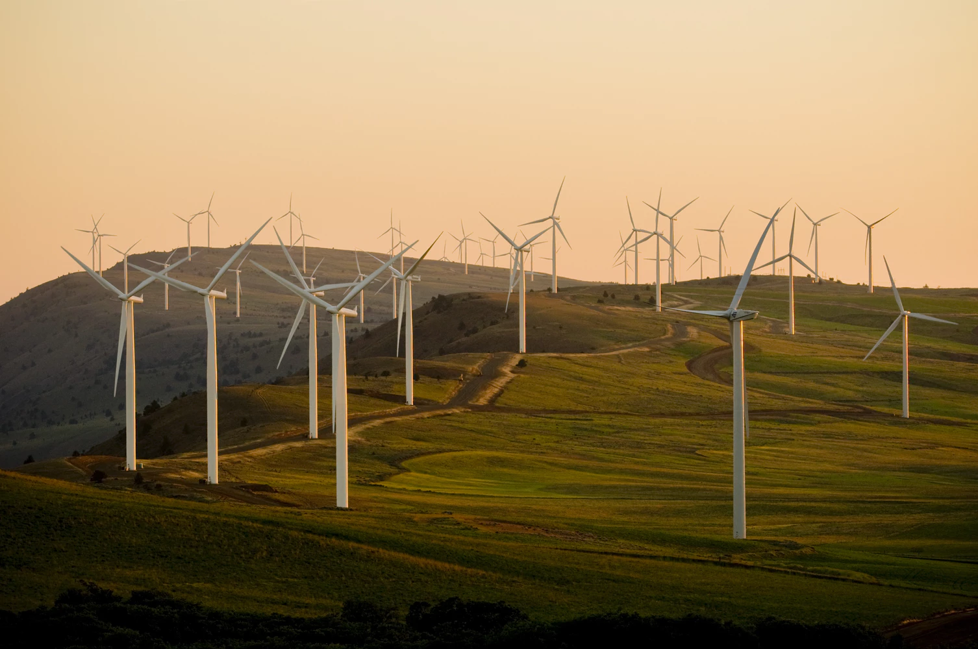

The second type is solar power. This technology includes the solar photovoltaic panels that convert light energy into electricity. The solar power does not do harm to the atmosphere, otherwise, it reduces warming pollution and has no negative impact on public and wild health. On the other hand, the process of installing does affect the location where the system is being set up because of excessive water and land usage with hazardous material included. 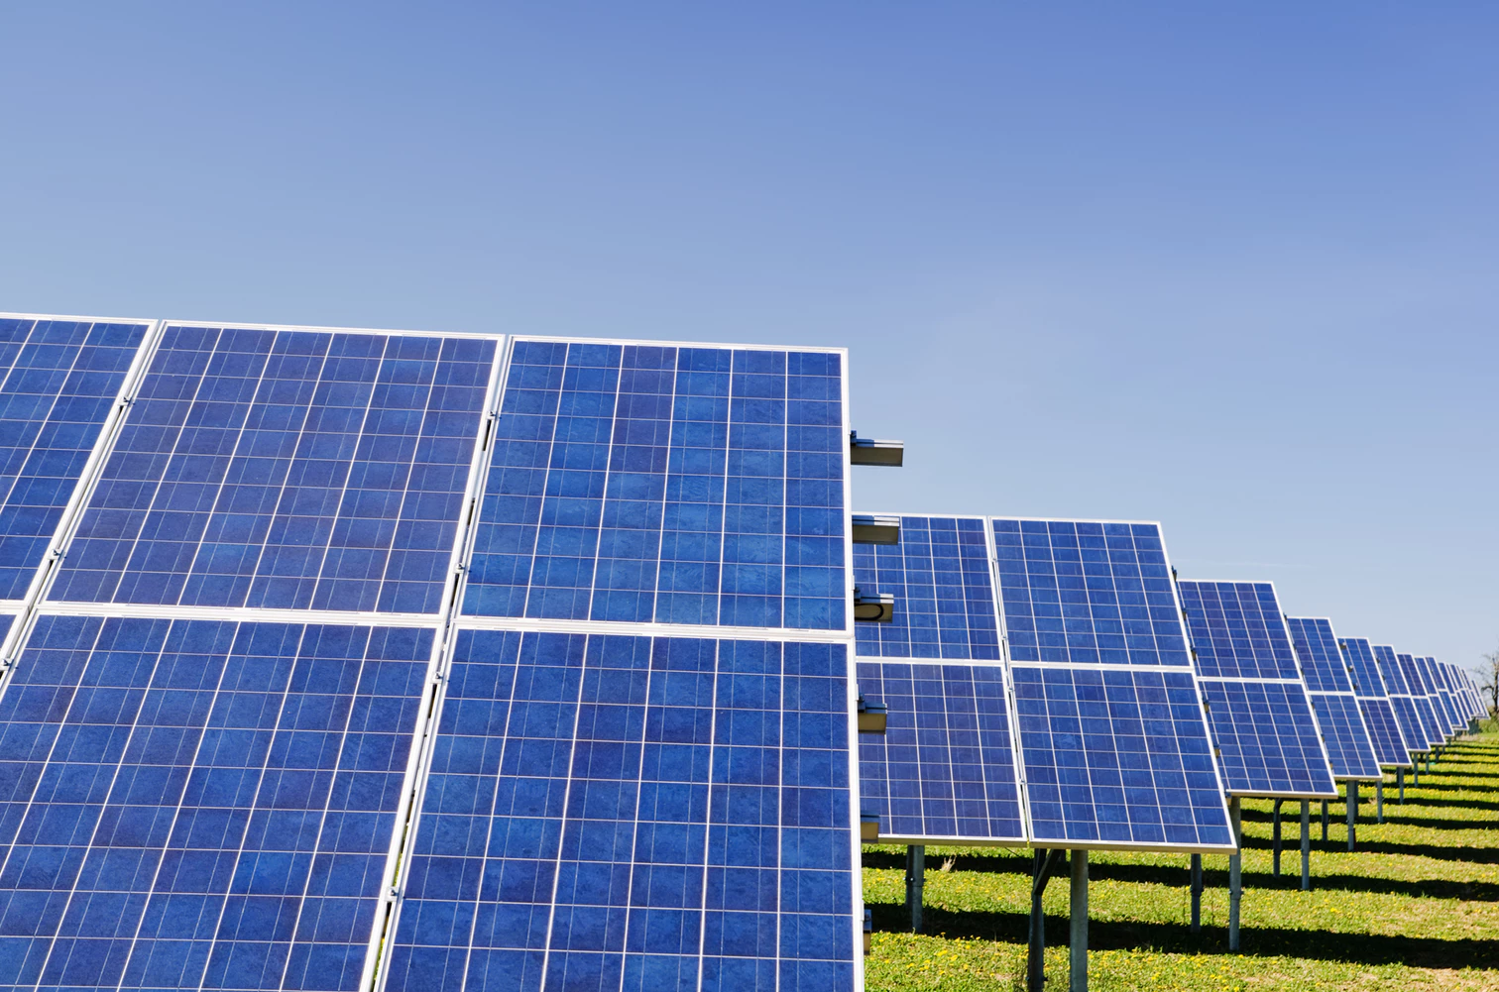

The third type, known as geothermal energy, uses earth’s heat to produce hot water and electricity in the phase of stem flash or binary. The union of scientists states that the water that comes from the power plants contains a dangerous amount of sulfur, salt, and other minerals. In addition, the direct steam into the atmosphere leads to global warming and the sulfide that changes into sulfur dioxide results acidic rains which destroyed agriculture and cause heart and lung disease in human beings. To install the geothermal factory, a big piece of land is needed. To get the energy from the earth center, the machines drill through the land surface thus increasing the level of earthquake risk.

The fourth type of electricity production is biomass. Biomass power plants and fossil fuels plants are alike, they are cultivated similarly and involve burning of a feedstock to produce electricity. There is also a huge difference between those two, the biomass power plant is determined as a renewable energy source and the fossil fuel is not. In addition, the biomass energy production results in an agricultural waste which consequences global warming emissions.

The fifth source of energy production is hydroelectric power. This power source is in the list of safe energy productions because it does not result in global warming nor air pollutants. The process includes a hydroelectric dam through which the kinetic energy of the moving water converts to electricity via gravitational force. The speeding water causes the turbine to spin at the same time generating the electricity. Hydroelectric plants require a lot of flooding land that leads to a horrible impact on wildlife, forests, and agricultural land areas. Also, besides negative effects, let's review so positively once too. First of all, hydroelectric power improves public health and it is an inexhaustible energy source. Furthermore, to run the system a labor force is needed which benefits job availability; plus, it brings stable energy prices because the hydroelectric plant is a renewable source. 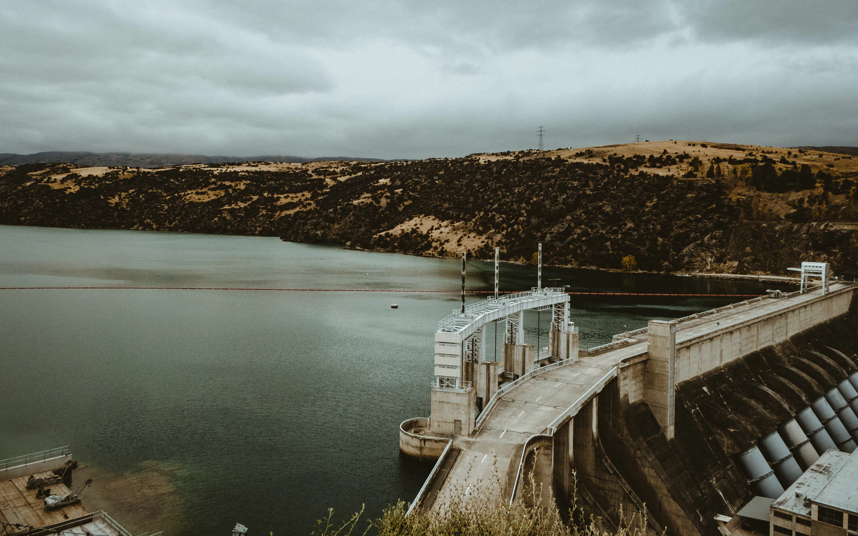

The sixth and final source is hydrokinetic energy. This energy system works via water waves and tidal power. The device is harmless to the atmosphere but its turbine creates a significant noise that effects water life. The economic point of view gives positive feedback because stronger currents and larges waves will implement highly available, almost the lowest prices on electricity.

The biofuel came along to replace harmful fossil fuels that were and still are used for energy purposes. The biofuel carries much more benefits, for example, it gives financial stability because it is a renewable source, the retail cost will be much less, and it does pollute the environment as much as coil and oil combustion. Before this global idea, people where investing trillions of dollars to advance fossil fuel infrastructure to use, develop and export. According to the article “The future of Energy: Clean and Green” author Kumar states“While biofuels would require some modification of this infrastructure, it would be substantially less than for a pure electricity infrastructure that might arise from the adoption of solar or nuclear technology” (Kumar, 2009, p. 11). Each year the human population grows by millions of people and in the next fifty years will increase in about fifty percent. It is a huge increase which will affect as environmental the same as the economic side of the issue. Currently, US society uses about 4 Terawatts of energy every year. Based on this information that is provided for the “Clean and Green” article, the non-renewable energy sources won't be enough for that bog of a population. As reported by the CEO of CombiMatrix, “This population growth, coupled with worldwide economic growth and improvements in standards of living, will increase the demand by a factor of 2 to 32 TW” (Kumar, 2009, p. 11). This means that this problem needs a solution and the biofuel is one of the best and cheapest ways to advance clean energy production without destroying the ecosystem.

A school is a place where people spend a third of there life studying and learning new things for their careers. Consider how much electricity the school is using for the classrooms, some schools have gas boilers for heating the place. The amount of energy usage is really surprising due to the age of the building and materials that were used to build it. Schools that are built over decades ago, required to meet the right indoor and outdoor environment modification standards. In addition, the U.S. Green Building Council (USGBC) have always thought about the green environment for any type of buildings. To increase the school’s green environment, the additional budget is needed. Furthermore, each school is required to follow the standards of Leadership in Energy and Environmental Design (LEED). In article “The Next Generation of LEED” author Katz described LEED as “… all LEED rating systems for commercial buildings; new, transparent credit weightings based on environmental and human health impacts; a methodology for incorporating bio regionally specific credits: and a two-year development cycle” (Katz, 2008, p. 36). The idea of LEED is to give points to the school’s specific features like a football field that can be rented by facilities or by other group members besides students for other purposes. Eventually, the LEED program rates the building upon on how many points had been earned. Such programs are becoming more and more common in our days because they guarantee an investment of grants to the school. It helps the school to develop and use the grants to accommodate the needs of students and provide a better education. LEED certification also giving points for indoor environmental quality. It includes the emission standards and LEED green building rating system for building’s products and materials which may include environmental hazards. According to the article “Indoor Environmental Quality” the research supports, “Studies have shown that people who work in green buildings are more productive and take fewer sick days” (Fox, 2007, p. 36). 

As a matter of fact, the location of the school won't change for a long time, but as long as the school will remain an energy consumer, the building will do an impact on the ecological surrounding. By using the right materials and reinventing the way of delivering clean energy to the classrooms won’t require rebuilding an entire building, it just requires an alternative approach to the existing school system. Author of “Green Light on energy use” article references one of California schools that uses the energy saving system. Carl Vogel writes, “The school’s geothermal system uses 71 heat pumps, four energy heat recovery units and 47 miles of underground pipe to heat and cool the building, using less energy than a conventional system…” (Vogel, 2007, p. 31). What it means is that if the school will replace the conventional system to geothermal system then the final result will benefit not only school budget, but it will also bring less harm to the environment.

In summary, green energy technologies are a much better alternative to harmful fossil fuels. They do not carry as much danger to the planet as coil and oil combustion. According to five sources that are explained in paragraphs above, the renewable sources of energy, for examples, such as wind, solar, geothermal, biomass, hydropower, and biofuels lowered or even reduced the risk of global warming including the air and water pollution. Those inventions are not only climate rescuers but are also financially beneficial. They do not necessarily make the environment perfectly clean because any process that involves energy contribution is foreign to nature and carries a small percent negative impact on the ecosystem. To keep out atmosphere clean and to save public health, places like schools that have a huge impact on students should follow LEED certificate standard for environmental and educational purposes.

## **Reference:**

*Environmental Impacts of Renewable Energy Technologies*. (2016). Retrieved from<https://www.ucsusa.org/clean-energy/renewable-energy/environmental-impacts>

Fox, T. (2007). *Indoor Environmental Quality*. Environmental Design & Construction, 10(3), 36–38. Retrieved from<http://search.ebscohost.com.proxy.devry.edu:5050/login.aspx?direct=true&db=8gh&AN=24429630&site=ehost-live>

Katz, A. (2008). *The Next Generation of LEED*. Sustainable Facility, 33(4), 34–36. Retrieved from<http://search.ebscohost.com.proxy.devry.edu:5050/login.aspx?direct=true&db=8gh&AN=33240283&site=ehost-live>

Kumar, A. (2009). *The Future of Energy: Clean and Green*. Siliconindia, 12(1), 10–11. Retrieved from<http://search.ebscohost.com.proxy.devry.edu:5050/login.aspx?direct=true&db=8gh&AN=36571267&site=ehost-live>

Vogel, C. (2007). *Green Light on Energy Use*. (cover story). District Administration, 43(11), 28–34. Retrieved from<http://search.ebscohost.com.proxy.devry.edu:5050/login.aspx?direct=true&db=8gh&AN=27477394&site=ehost-live>